**ToDo List App Technical Documentation**

**Chapter 1**

This chapter contains what the application can do and its workaround. It is also indicated in the chapter on the overview of this application.

ToDo List App is web application which allows user to do the following:

* Add new To-Do activity
* Edit/Modify a particular To-Do activity
* Delete/Remove a particular/all To-Do activities
* Ability to mark particular activity/all activity as either active or completed
* Display all, active, and completed To-Do activities

**Chapter 2**

This chapter contains the installation process, Starting the application, Using the application, Software Design pattern, Bugs/Error fixing, and the Test results.

**Installation**

Before installing you must first have the following software installed in order to have this project on your local machine. You must have installed ***NodeJS*** (A JavaScript engine), and ***Git***, an open-source version control software.

To install this application (ToDo List App), you must have download from this link -> [https://github.com/joliveramu/oc-frontend/tree/master/P8_John%20Oliver].

Once downloaded, open your terminal/command line in order for you to navigate in the project ***P8_John Oliver*** folder then to the ***todo-list-app-fixed*** folder. As you are in the ***todo-list-app-fixed*** folder, in your terminal, type the command ***npm install*** in order to install all dependencies that this application needs.

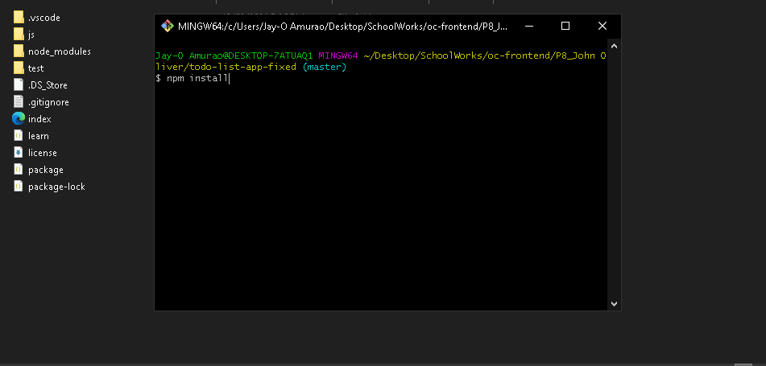

Once everything is installed, we will now proceed on how to start the application.

**Starting the application**

To start this application, you may simply run the ***index.html*** in your browser of preference.

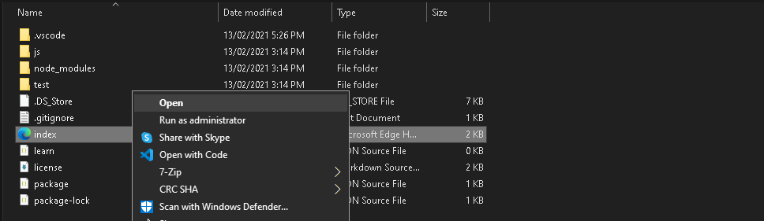

In order for you to view the unit testing results, inside the ***todo-list-app-fixed*** folder, navigate to the ***test*** folder and look for the ***SpecRunner.html***. You may run the web page in any browser of your preference.

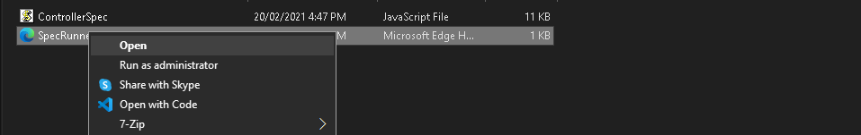

**Using the application**

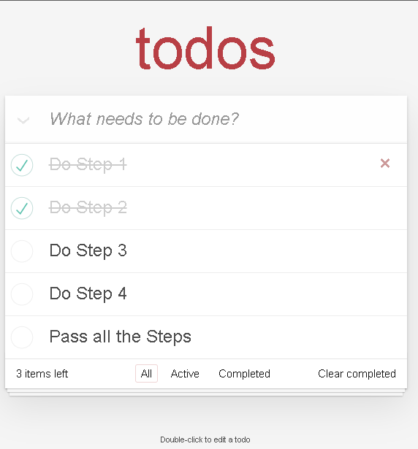

* To add new To-do activity, simply click onto field with text ***What needs to be done?*** type name of new To-do activity and press enter.
* To change name of existing To-do activity, double click the name of a particular activity and press enter after finish editing.
* To change status of an active To-do activity to completed or active, simply click the circular checkbox before the name of a particular To-do activity
* To change status of all active To-do activities to all completed completed or all active to-do activities, click the dropdown icon besides the ***What needs to be done?*** field.
* In order to see how many activities are still active, there’s a notification bar below (Beside All, Active, and Completed navigation bar)
* This filter buttons (All, Active, and Completed) will let you change view to display all To-do activities or only active or completed To-do activities.
* To delete one active or completed To-do activity, hover over its name and click this X icon once it appears.
* To delete all completed To-do activities, click the ***Clear completed***.

**Software Design Pattern**

This application uses a MVC architecture where **MVC** stands for **Model-View-Controller.** The Model, View, and Controller are different entities from each other.

1. ***MODEL***  
   Model is responsible for managing the data of the application. It receives user input from the controller. He is responsible for CRUD (create, read, update and delete) operations. Our model is using local storage to save our todos.
2. ***VIEW***  
   View is a presentation of the model in a particular format - in our case displaying All, Active or Completed todos (**route**). It also let user to interact with displayed data.
3. ***CONTROLLER***  
   Controller responds to the user input from View and performs interactions with Model. It also reading data from Model and passing it to the view.

By using MVC architecture, our application works like Single Page Application (SPA) - that means user can interact with todos without reloading webpage.

**Bugs/Error fixing**

This part contains the bugs/error fixing encountered through the application.

* **js/Controller.js** line 95

Misspelled function name

Controller.prototype.adddItem = function (title) {

**Changed to**

    Controller.prototype.addItem = function (title) {

* **js/Controller.js** line 169

Unnecessary line of code

    items.forEach(function(item) {

          if (item.id === id) {

              console.log("Element with ID: " + id + " has been removed.");

          }

         });

* **js/Store.js** line 89

This line of code may produce an ID conflict in the near future. There are chances that the ID that would be generated here produce a duplicate.

/* Original Code Edit 1 */

     Generate an ID

     var newId = "";

     var charset = "0123456789";

     for (var i = 0; i < 6; i++) {

       newId += charset.charAt(Math.floor(Math.random() * charset.length));

     }

**Changed to**

// Generate an ID

    // Displays date in numerical format

    var newId = Date.now();

Which makes the generated ID progressive

* **index.html** line 16

Added id element name ***toggle-all***

<input class="toggle-all" type="checkbox">

**Changed to**

<input id="toggle-all" class="toggle-all" type="checkbox"/>

**Tests**

The testing was done using the Jasmine JS framework. ***Jasmine****JS* is an open-source testing framework for JavaScript.

To start test simply start ***SpecRunner.html*** file located in application main directory in ***test*** folder.

To create or modify tests open and modify ***ControllerSpec.js*** file located in the same directory where you have created the project.

**Below are the Nine (9) additional tests that has been added to the existing tests in the *test/ControllerSpec.js*:**

* should show entries on start-up
* should show active entries
* should show completed entries
* should highlight "All" filter by default
* should highlight "Active" filter when switching to active view
* should toggle all todos to completed
* should update the view
* should add a new todo to the model
* should remove an entry from the model

**Screenshot of the Successful tests added**

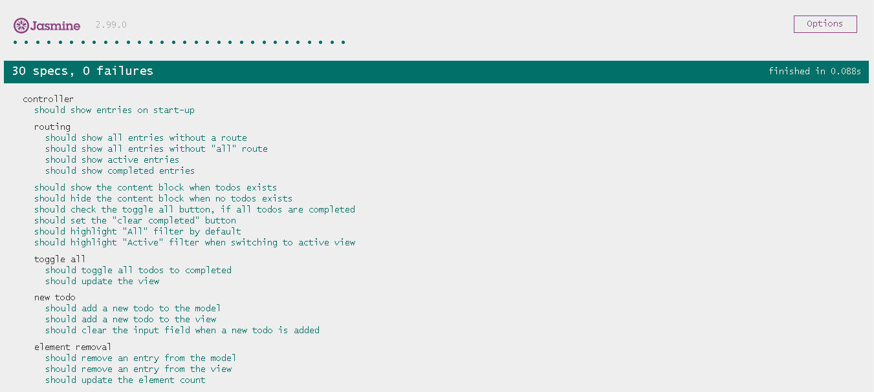

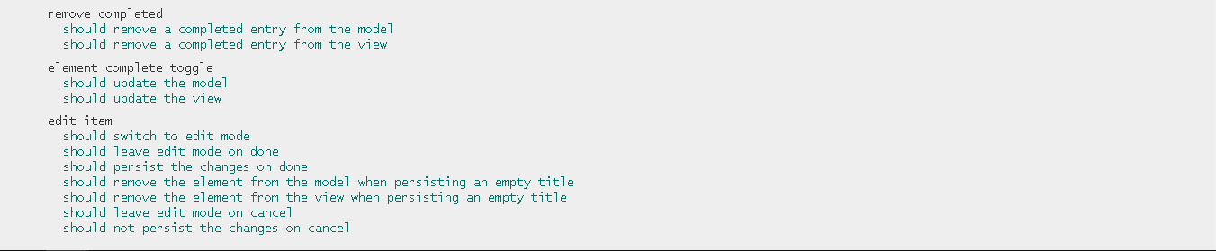

**Performance Audit**

**ToDo List App (Our Application audit)**

**Network**

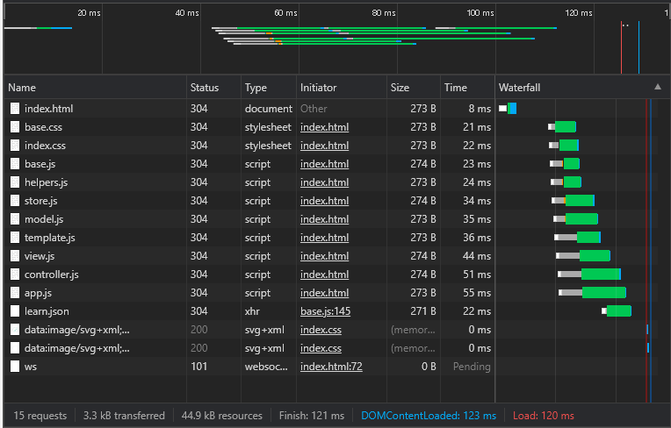

**Performance**

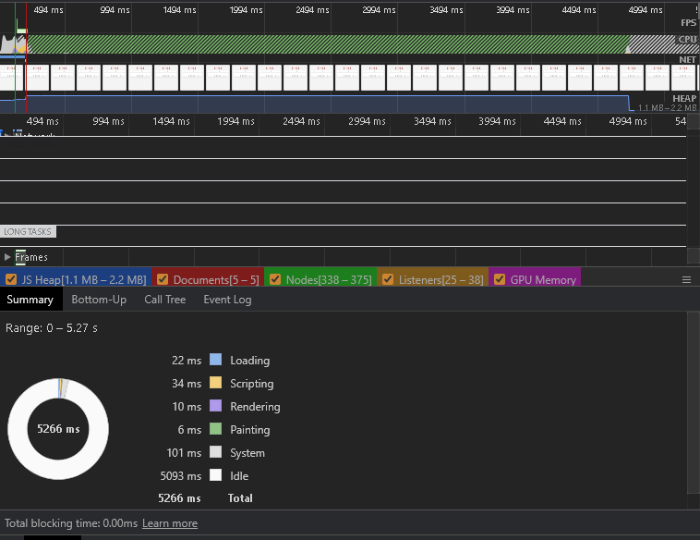

**Memory**

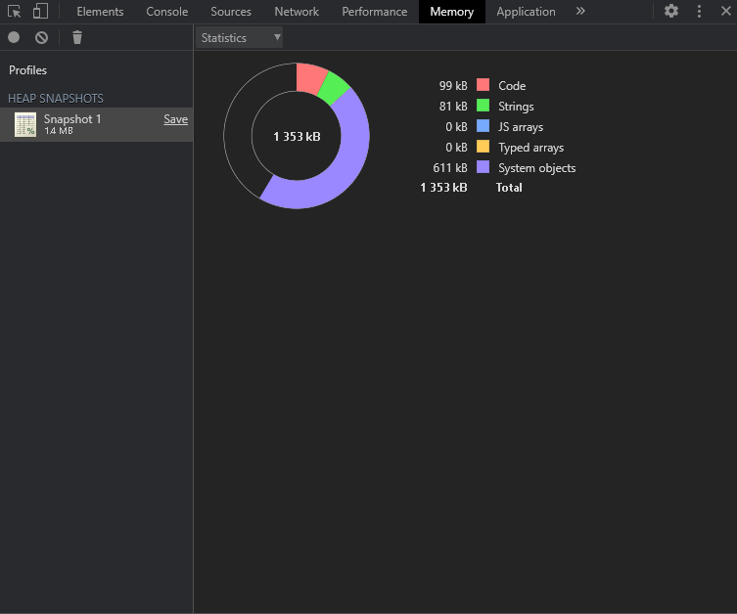

**Todolistme** (Competitor website audit ***(http://todolistme.net/)***)

**Network**

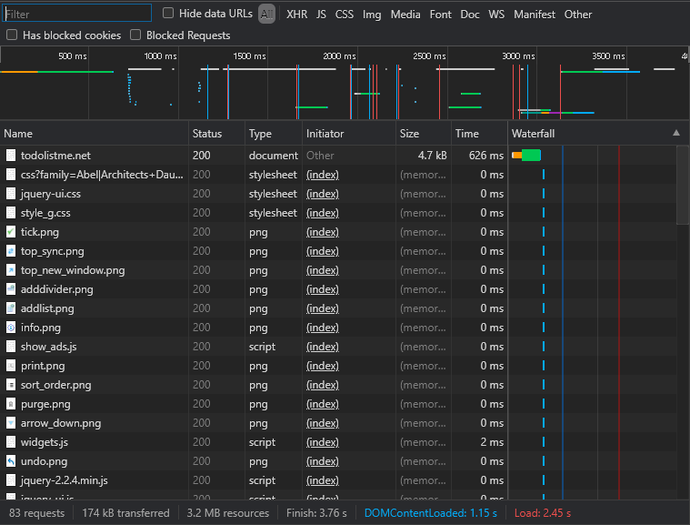

**Performance**

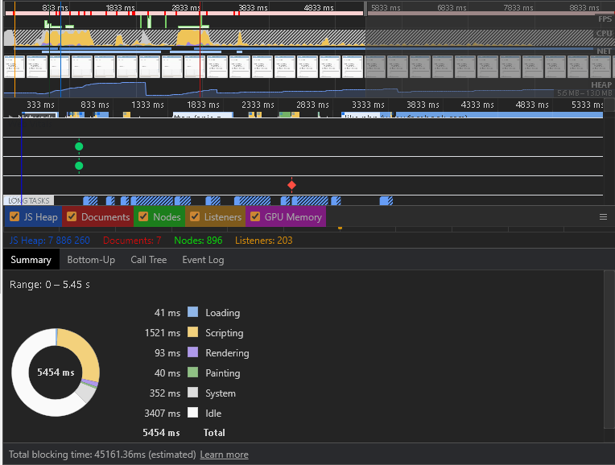

**Memory**

